Higgs Boson
  - Students Name

1.Introduction.

1.1 Part 1

In 1964 Higgs created a theory that suggested the existence of the particle, which was named Higgs-Boson. The theory stated that there must be a subatomic particle of a certain dimension that would explain how other particles acquired mass [1], and therefore all matter in the universe.

In the mid-20th century, many experiments demonstrated the presence of mass in particles, through the exchange of which fundamental interactions are described. Therefore, it was necessary to introduce an expression for the mass into the equations of motion for these particles. Equations of motion for gauge fields with mass terms are not invariant under local symmetry transformations; that is, these equations will change under gauge transformations. The properties of fundamental interactions, however, require that the equations of motion remain unchanged under gauge transformations, so simply introducing mass terms would violate the laws of nature.

Higgs's breakthrough was that the mass of a vector boson effectively arises as a result of a specific interaction between this boson and a scalar field. This mechanism was proposed in the context of the spontaneous breaking of the electroweak symmetry model developed by Yoichiro Nambu and others in an attempt to explain the nature of the strong interaction. Higgs and other researchers developed this mechanism primarily for the case of non-Abelian symmetry groups.

The Higgs theory was anticipated by Ernst Stückelberg in 1957. Higgs himself based his theory on a suggestion by Philip Anderson. The idea for the mechanism came to him while hiking in the Scottish Highlands. Independently of Higgs, Robert Brout and François Englert of the Free University of Brussels, as well as D.S. Guralnik, K.R. Hagen, and T.W.B. Kibble of Imperial College, reached similar conclusions[2].

We can’t detect the Higgs-Boson because its decay time is approximately ${10}^{-22}$ seconds, however we can detect the result of its decay, for example it could be four electrons or a pair of photons [3]. In the case of two photons, initial mass can be calculated using this formula:
$$m_{γγ}=\sqrt{{(E_{1}+E_{2})}^{2}-{({\vec{p}}_{1}+{\vec{p}}_{2})}^{2}}$$
Where E is an energy of each photon and $\vec{p}$ is their impulse.
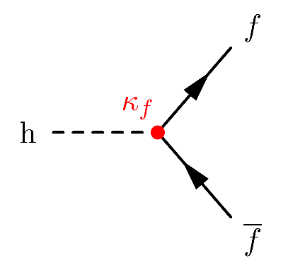
Figure 1 Feynman diagram of Higgs boson decay into two photons.

1.2 Part 2

The ATLAS Collaboration has examined its complete Run 1 dataset, comprising proton to proton collisions at 7 and 8 TeV delivered by the Large Hadron Collider, and to obtain a precise determination of the Higgs boson mass. In this analysis, the Higgs boson appears as a narrow resonance in the invariant-mass distributions of its decay channels into two photons or into four charged leptons, as illustrated in the Figure 1 [4]. Summary of results is displayed in Table 1.

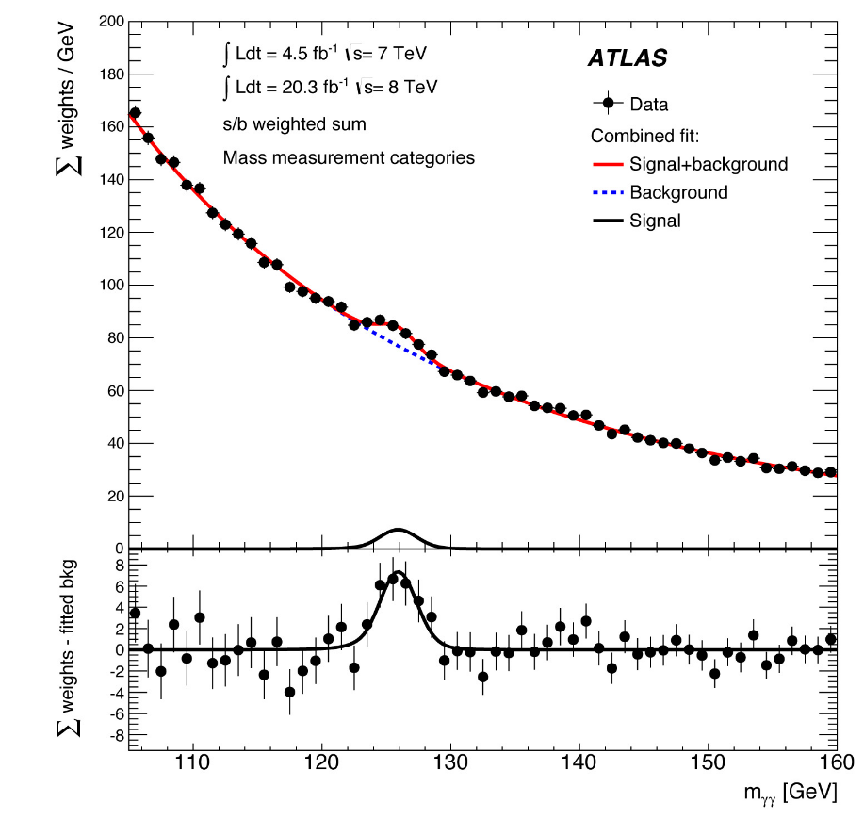
Figure 2Measured mass spectra of Higgs candidates reconstructed in events containing two photons. (Image: ATLAS Experiment/CERN)

By locating this peak above the smooth background, ATLAS measures the mass of the resonance to be 125.36 ± 0.41 GeV, which is roughly 130 times the proton mass, with a precision of about three parts per thousand. The measurement is primarily limited by statistical uncertainties, while instrumental uncertainties remain small thanks to extensive calibration efforts that have led to an exceptional understanding of the ATLAS detector’s performance. This result ranks among the most precise measurements achieved by the ATLAS Collaboration [5].

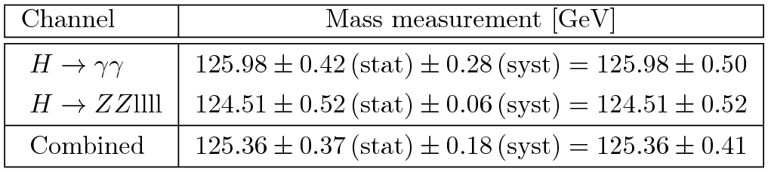
Table 1. Summary of Higgs boson mass measurements [5].

2.References
1] AP News. Peter Higgs. Accessed: 2025-11-29. 2025. url: https://apnews.
com/article/peter-higgs-boson-particle-has-died-94-25975f3de2621cd610b1062f9b440548.
[2] ATLAS Collaboration. ATLAS Collaboration: Combined measurements of
the Higgs boson mass in pp collisions at √s = 7 and 8 TeV with the ATLAS
detector. Accessed: 2025-11-29. 2015. url: https://atlas.web.cern.ch/
Atlas/GROUPS/PHYSICS/PAPERS/HIGG-2013-12/.
[3] ATLAS Collaboration (CERN). A precise measurement of the Higgs boson
mass. Accessed: 2025-11-29. 2025. url: https://atlas.cern/updates/
briefing/precise-measurement-higgs-boson-mass.
[4] CERN. Higgs boson: what is it? Accessed: 2025-11-29. 2025. url: https:
//home.cern/science/physics/higgs-boson/what#BEH.
[5] Feynm.net. Higgs boson decay and production mechanisms. Accessed: 2025-
11-29. 2025. url: https://feynm.net/higgs_decay/.

